Sharifa Isaako

Interaction Design

Assignment 3

Design Prototype and

Evaluation Report

91030913

Project: Whanau (Family) Calendar

Task 1

Overview of concept

If it’s not in the calendar it doesn’t exist! The family (whanau) calendar is a great collaborative family calendar that lets you and members share and create content together. It not only helps keep a track of your personal appointments but also other members schedules. Your entire family working together to get things done and you will always know what’s going on. Household management is vitally essential to help support survive our overloaded lifestyles. Including children alongside parents will generate a combined effort to further reduce additional weight to remember each other’s commitments. People use calendars frequently. An extensive large percentage use them every day more than once. Human-computer interaction (HCI) focuses on the design of computer technology and in particular the interaction between humans the users and computers. Calendars can help you organize your daily routines and keep a track of your to do lists, plus it’s a great tool to manage your time. Family members can set reminders, trainings, load sports, school related activities, play dates, assign tasks, pick up times, travel arrangements, sleepovers, chores, projects, due dates, reminders, to do lists, meetings, meals, even shopping lists. Color coded so you can quickly see who needs to be where and when.

The aim of this report. I have examined good and bad design, evaluated how to improve the designs. For any new design I have related key concepts of Interaction design. Some techniques I carried out competitor analysis using an heuristic evaluation. I have considered the UCD process with design thinking which included iteration and prototyping. I then used techniques to understand and define the users. The results of this data are then used in the next phase in the UCD process to develop an interactive prototype. This research will help develop the final design as a high-fidelity prototype. Now I can refine and further evaluate my design using usability testing. Usability testing involves getting users to complete tasks with your product. Think aloud techniques are used. I used techniques and resources, considered the user recommendations and have researched more as the importance of UCD is at the final interactive design. However, if at a later stage I decide to go back and further develop the product this will then start a whole new UCD process.

I have considered the user interface (UI) the visual look, feel and considered the user experience, the overall experience of the user while using the product. A clear and clean look, with easy buttons and functions on the screen. For example, to add a new event a button could be placed at the bottom right-hand corner. A user interface has three main outcomes: It should be easy for the user to become familiar with and competent in using during the first contact with the product. It should be easy for users to achieve their objective through using the product. It should be easy to recall the user interface and how to use it on subsequent uses. I will work creatively and improve the product while keeping the business goals in mind.

Task 2

Iteration 1 Initial design sketch

Initial sketches of each major screen, descriptions including key design aspects below:

(Home) Month View  Add Event View

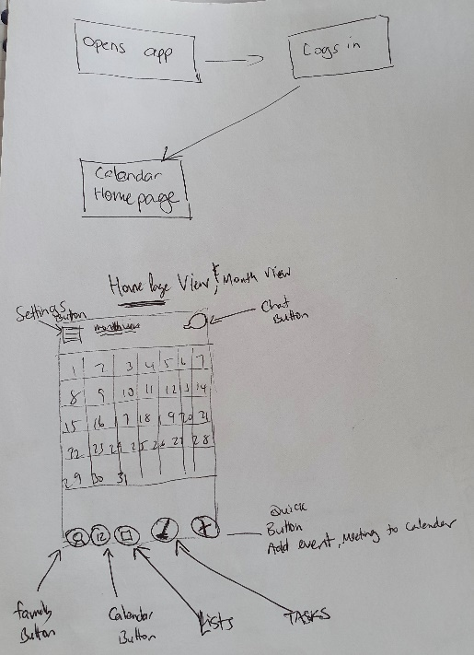 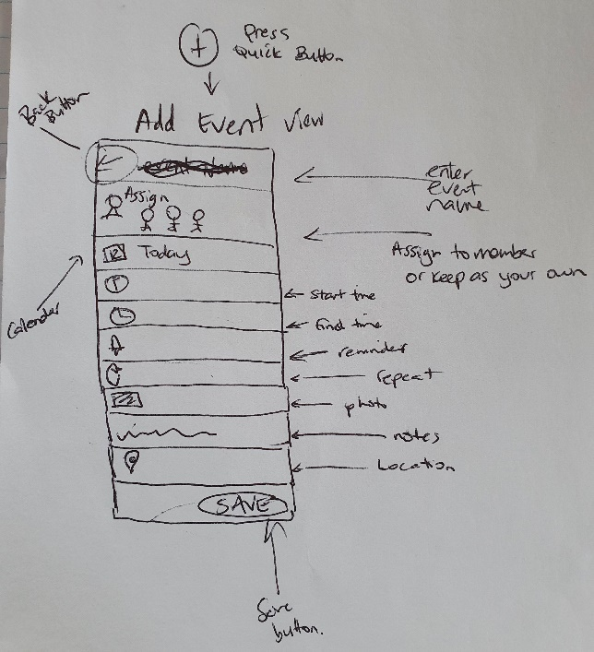

List View Add Task

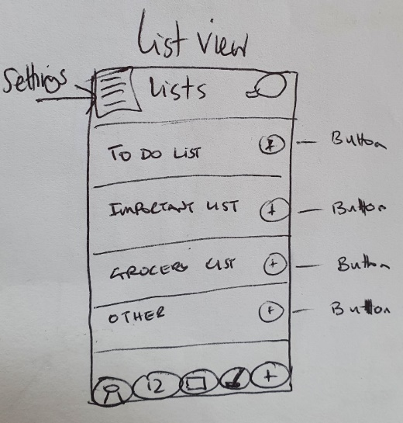 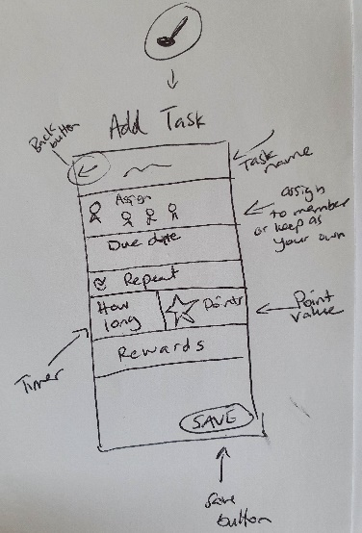

Family View Add Member

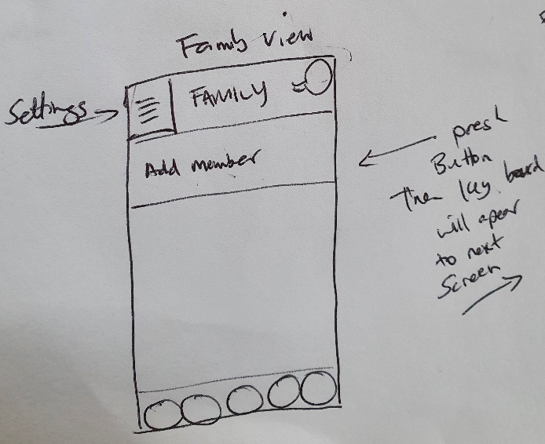 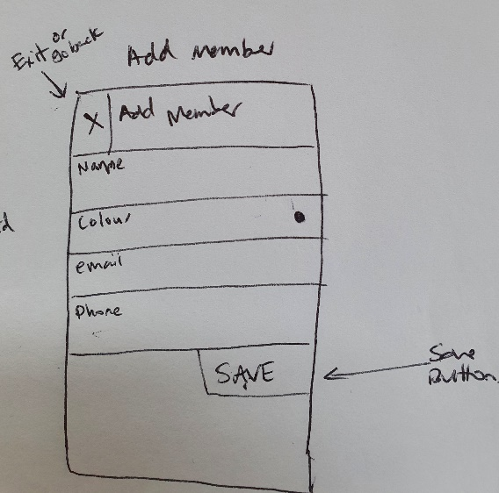

Grocery List

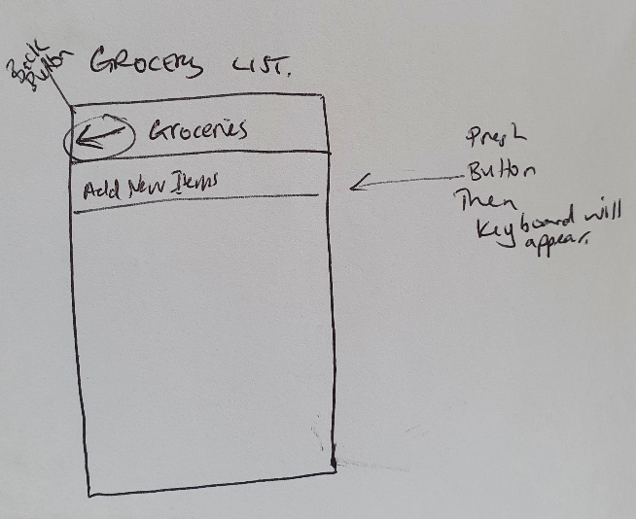

Chat View Individual chat view

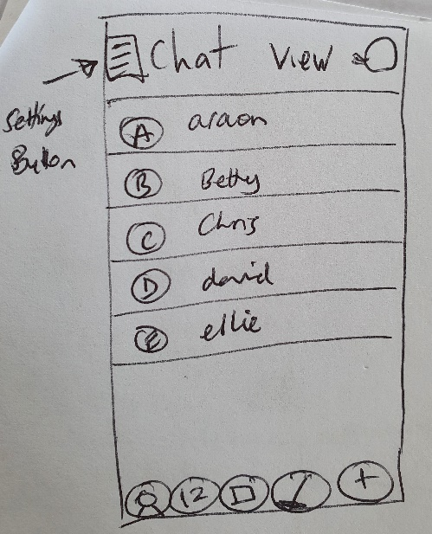 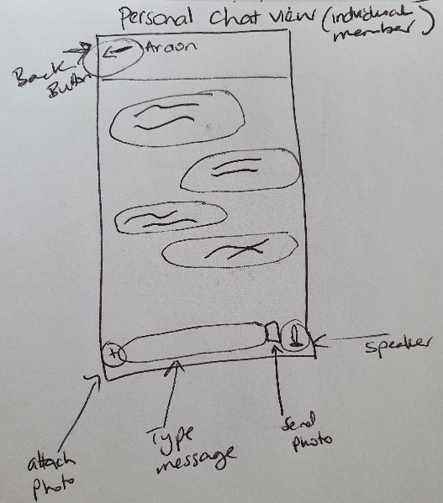

Settings

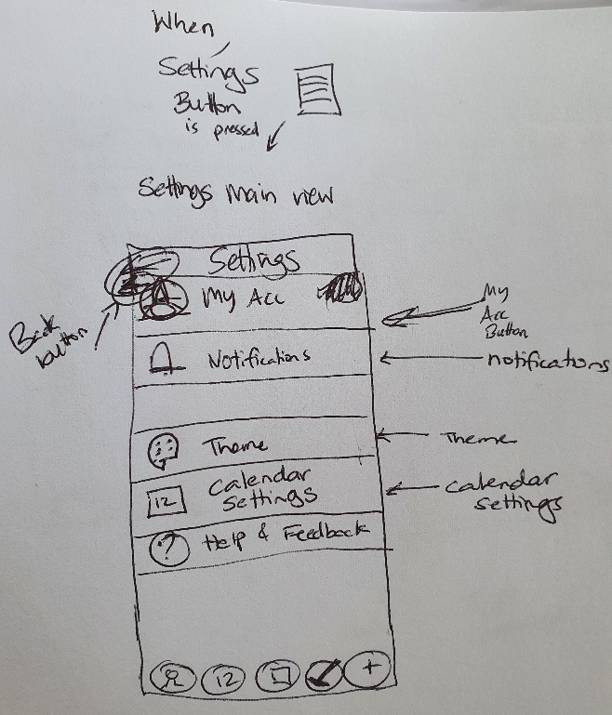

I held an Informal feedback session with three users. Questions included: likes and dislikes, overall satisfaction, and recommendations. This will give me ideas on improvements that will be applied within the final prototype. Below are the results:

Add a goal setting function in the list view.

Add event button could be larger than other buttons. One user would like it centred.

Bottom navigation could be rearranged.

Overall looks good and satisfied. Easy to use.

A future improvement very keen on group chats.

Maybe be able to scan a photo/image for automatic event created which adds to calendar.

Task 3

Iteration 2 Wireframe

Snapshots and a link to the interactive prototype below:

<https://marvelapp.com/prototype/g6c0ea0>

Login (Home) Month View

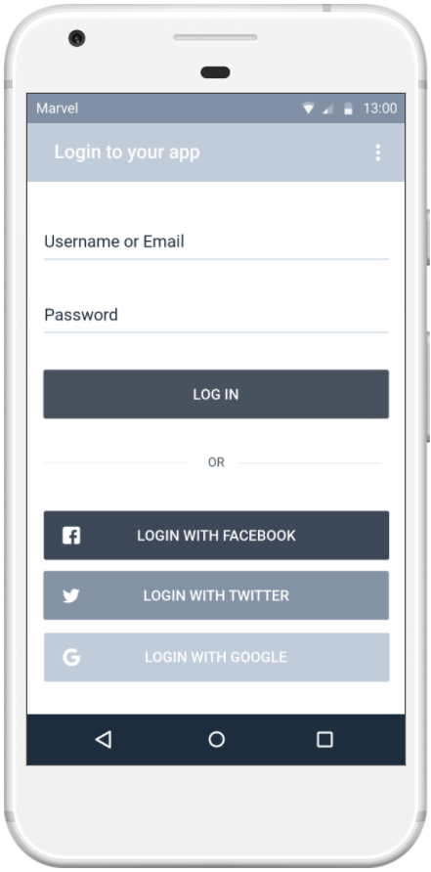 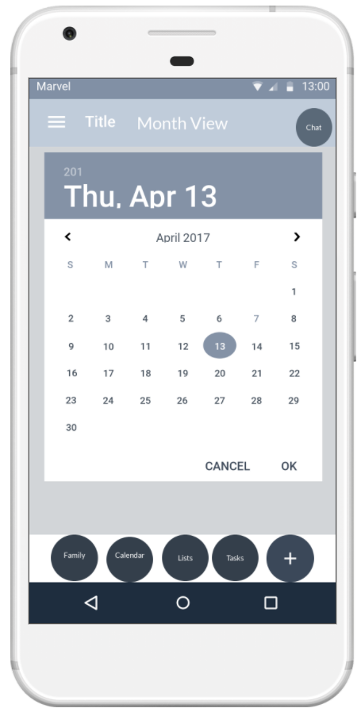

Screens below:

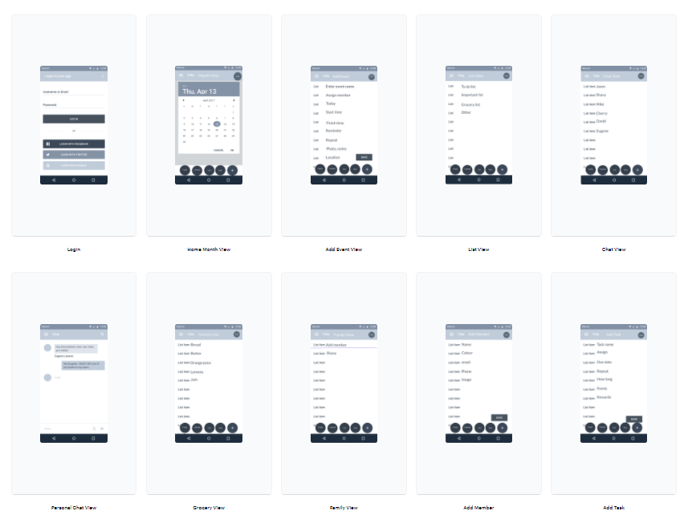 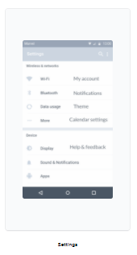

User flows link:

<https://userflows.marvelapp.com/g6c0ea0?utm_campaign=prototype-player&utm_source=other&utm_medium=web-app&utm_term=player&utm_content=userflows>

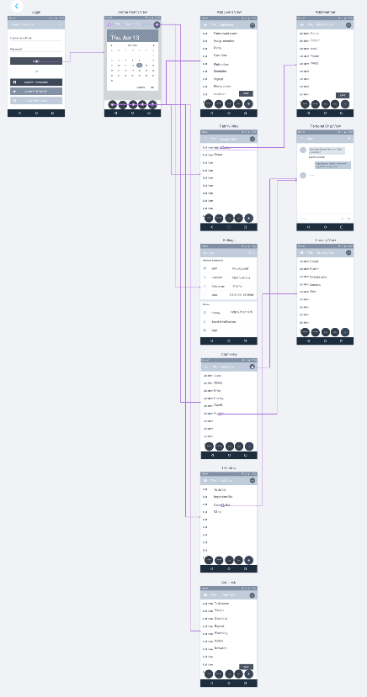

Task 4

Evaluation

Description of the reflection

In this section I had undertaken the formal user testing analysis involving three potential users. Two university students and a mother/student. The evaluation of the interactive prototype using surveys and observations to identify usability issues.

I designed scenarios explaining how the users will use the calendar app to fulfil their needs and goals from the feature list. The scenario included the user to view lists, grocery lists, create an event, assign a member to a task, change the theme. In the world of screens an example to create an event would look a bit like this; I click create an event. Fill out the text field and then hit the save button. The participants were asked to carry out the tasks.

The goal is to receive more meaningful feedback as interaction feels more real. This way it is easier to get a buy in from users and other stakeholders as it provides a clear idea of the final look.

With an open mind I created a survey, observation, and information sheets. I asked questions and listened to the user response this will ensure I am designing an effective product. One methodology I found effective is usability testing in person. The goal is to identify and usability issues. The think aloud technique helped me understand what the users are thinking to provide a deeper understanding. A follow up interview where I asked, follow up questions about the full app design and its features, its usefulness, user’s intention to use it and any barriers that would prevent them to user the app in the future. The feedback I found the plus create an event button to be centred in the middle and larger than other buttons so it would stand out more. All users hinted it is easy to use and did not get lost, not any trickly icons. They would recommend to parents, found it easy and fast to use. Overall experience result: moderately satisfied and slightly satisfied. I observed how fast a user who has never seen the app before can accomplish basic tasks efficiency with out errors. These goals were tested and observed as a combination. I also measured the effectiveness of the user needs and how accurately the tasks are completed. I observed the memorability where users after using the product can remember the app enough so they can use it effectively in future visits.

Final recommendations from the users would like group chats to be added and accessible. Be able to scan a photo/image for an automatic event view and save.

Task 5

Appendix

Evidence of evaluation below.

Copy of email as an invitation and thank you:

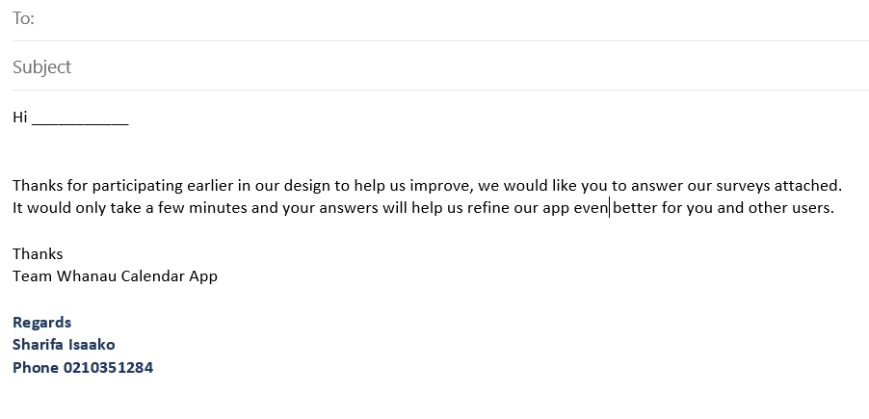

Completed observations sheets, Information sheets and notes:

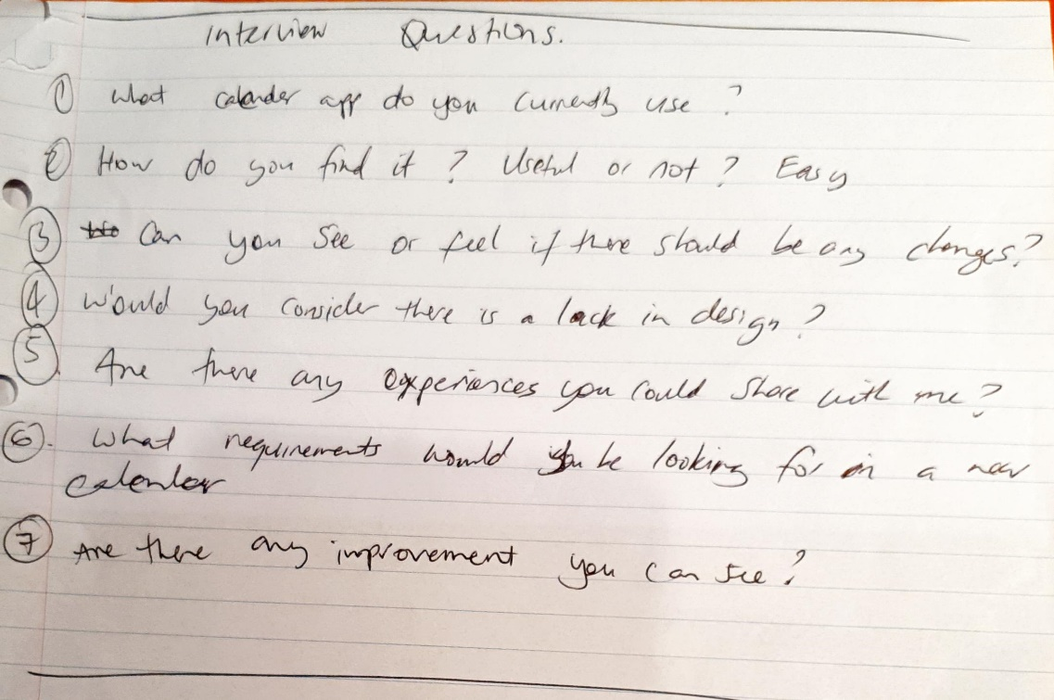

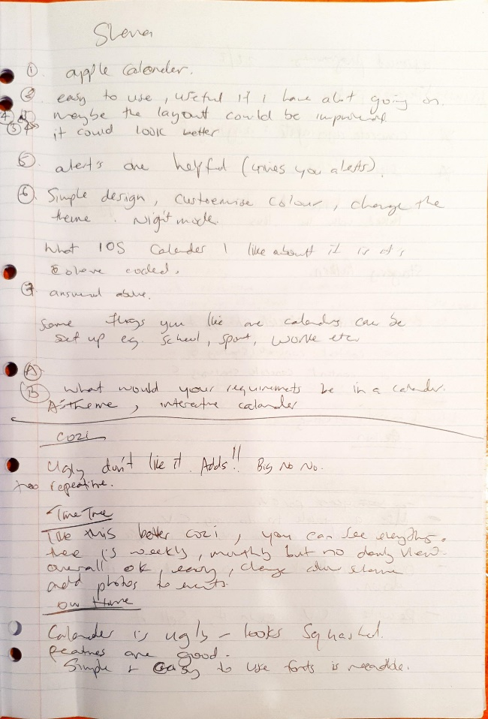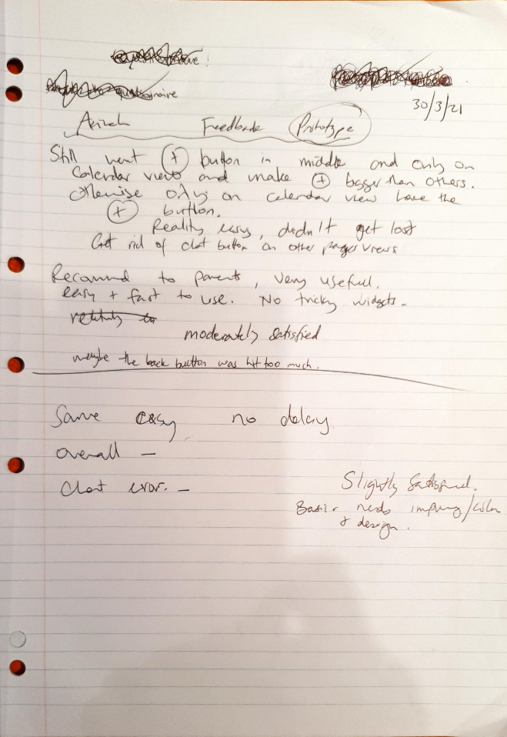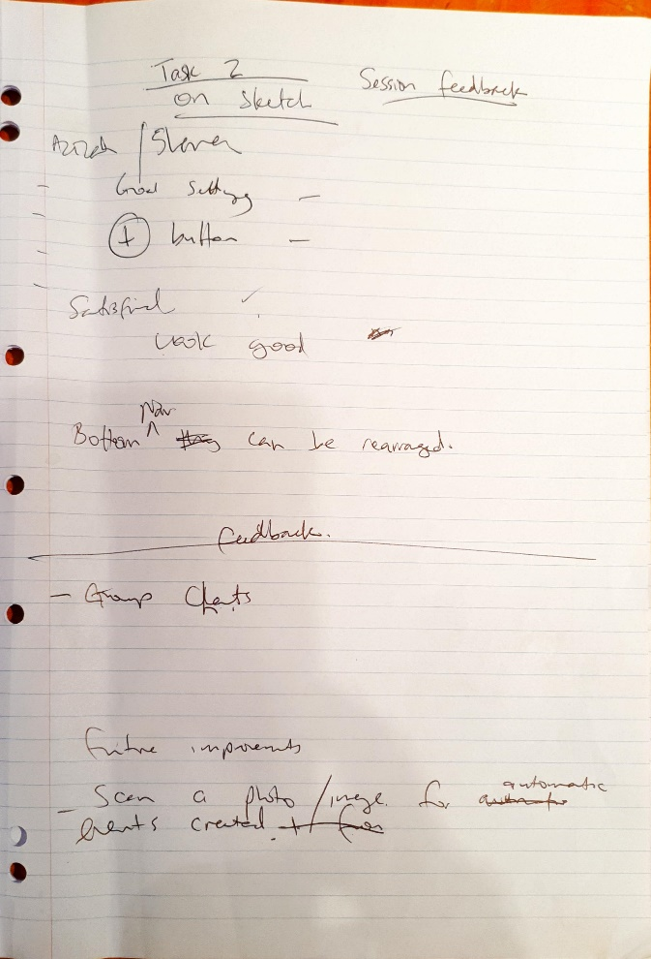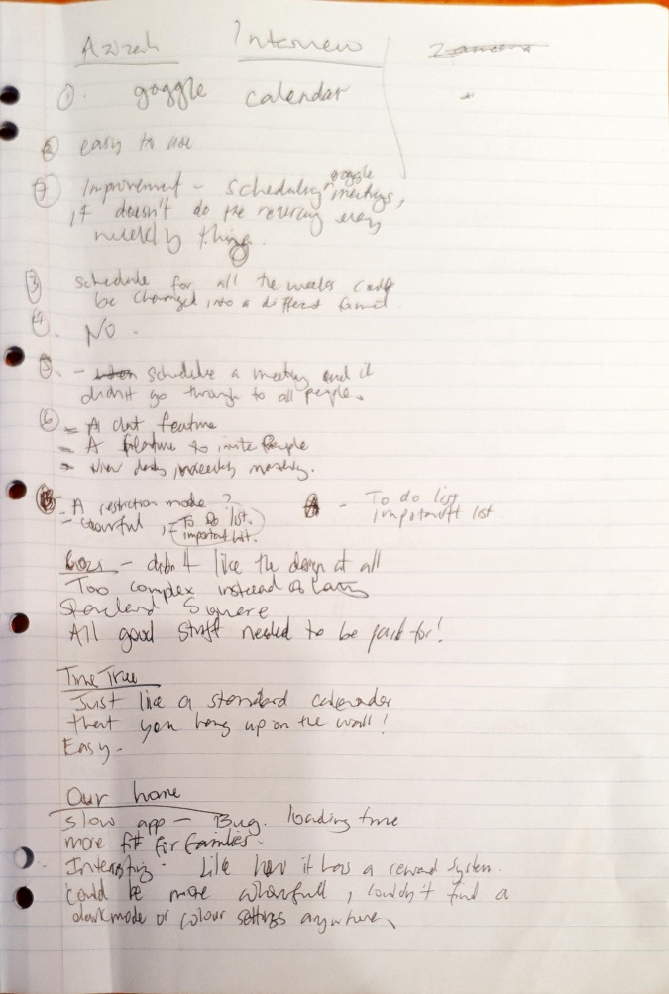

Completed surveys: Participant 1:

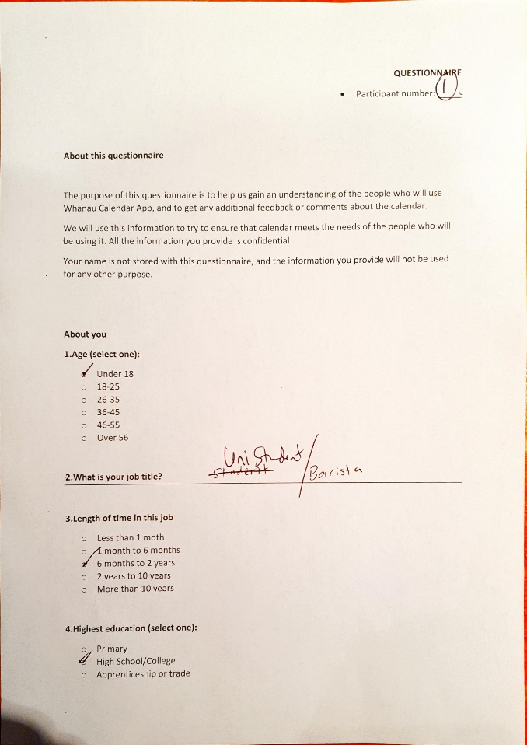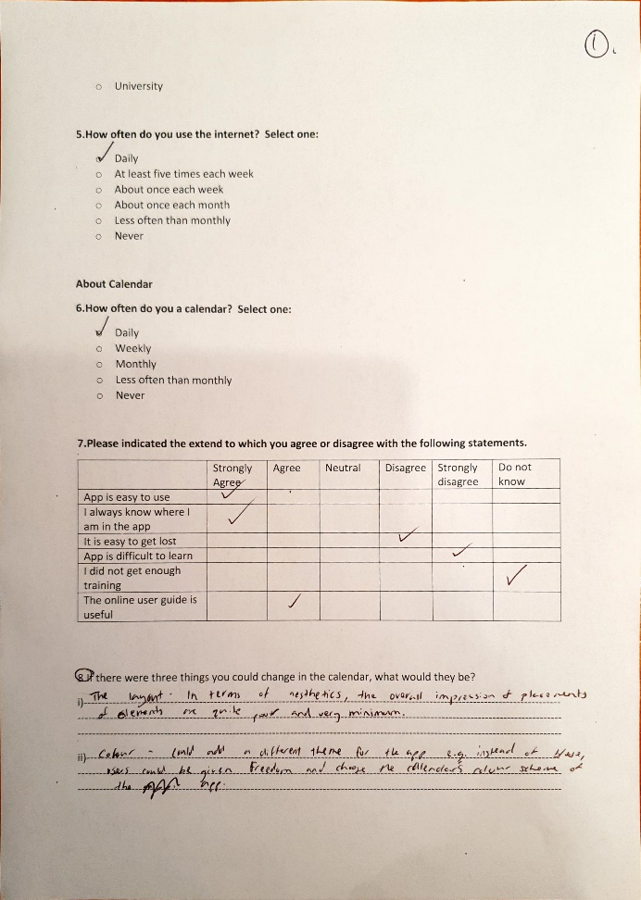

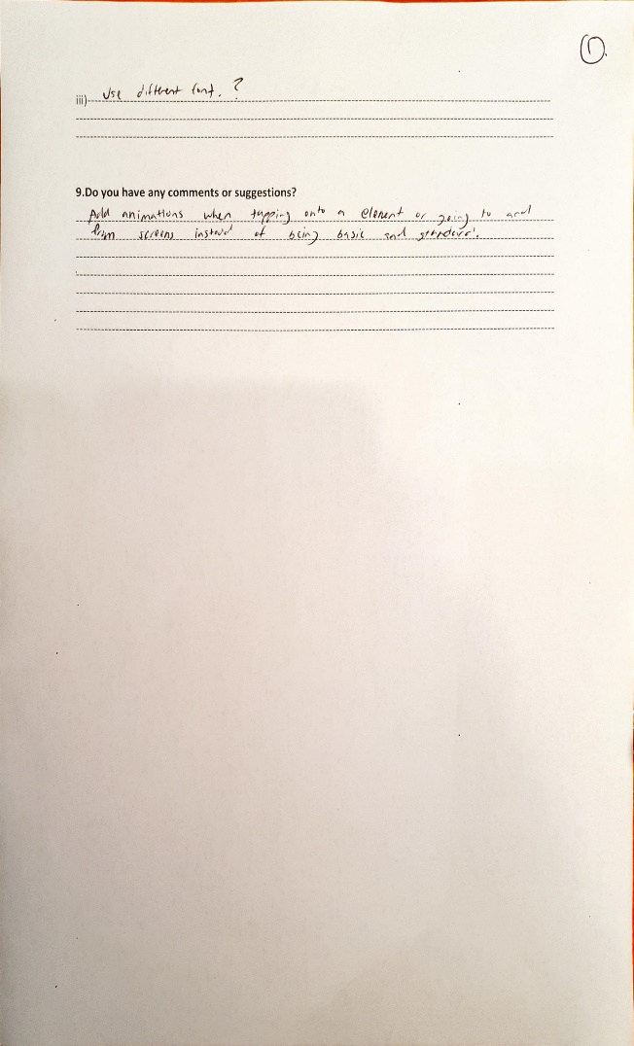

Participant 2:

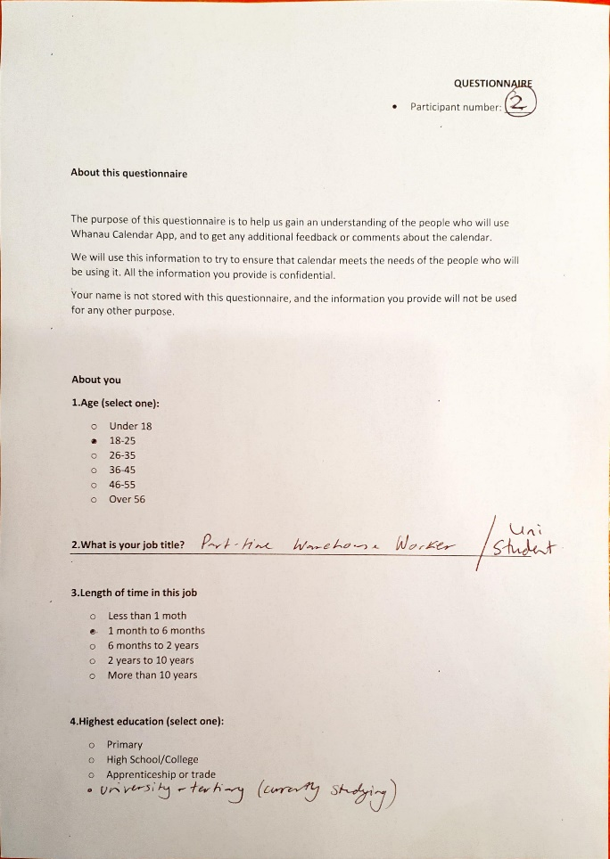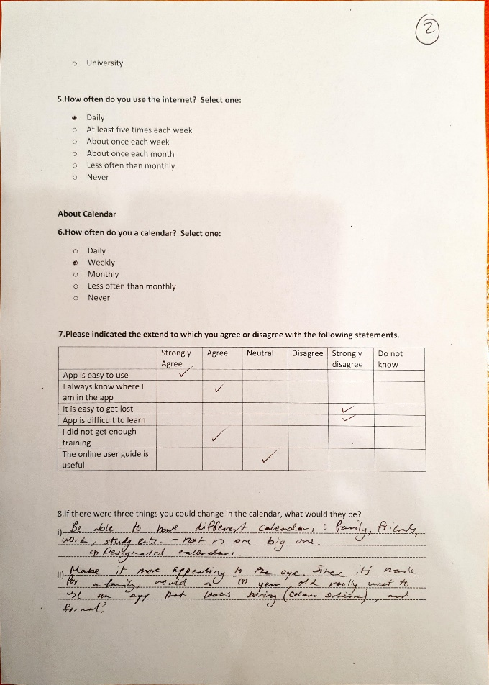

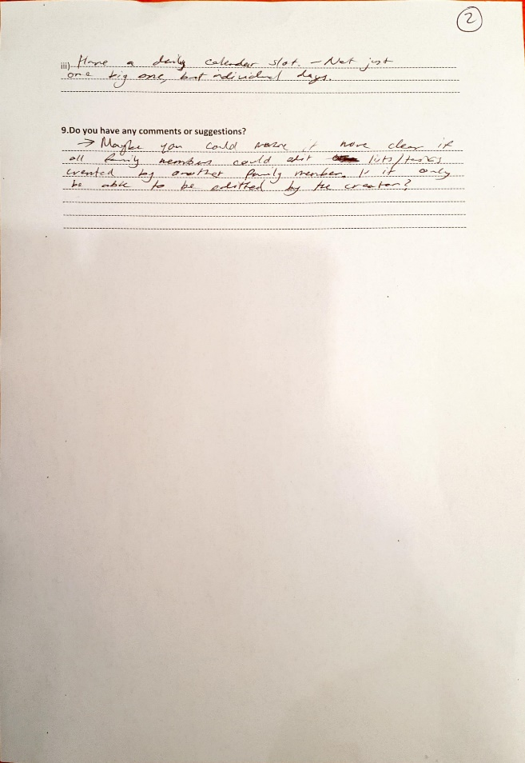

Participant 3:

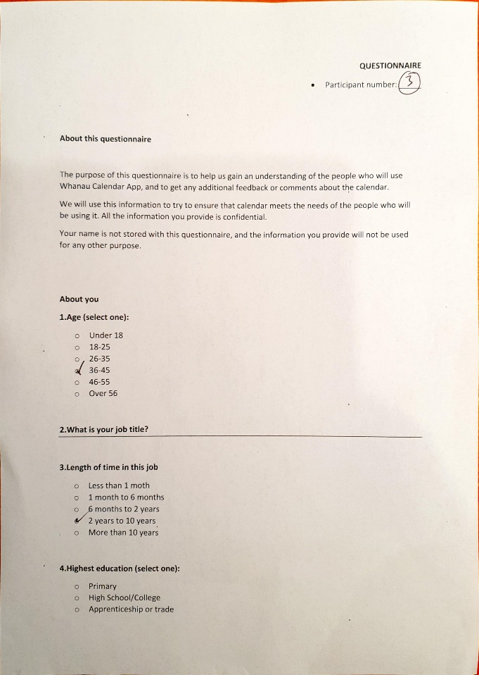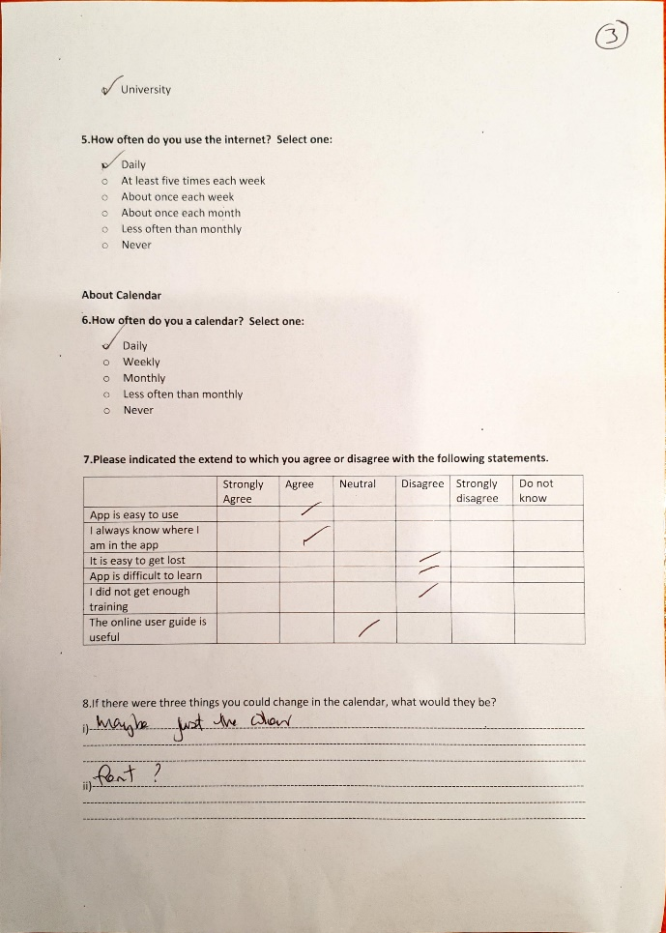

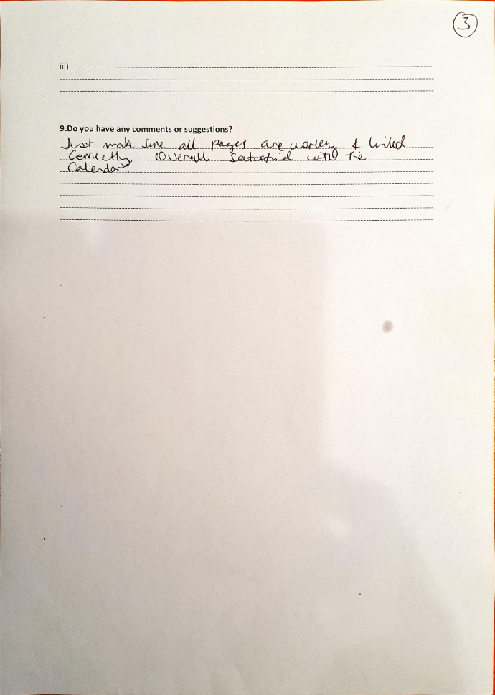

Collaboration tools:

<https://trello.com/b/7hVfUt4b/whanau-calendar>

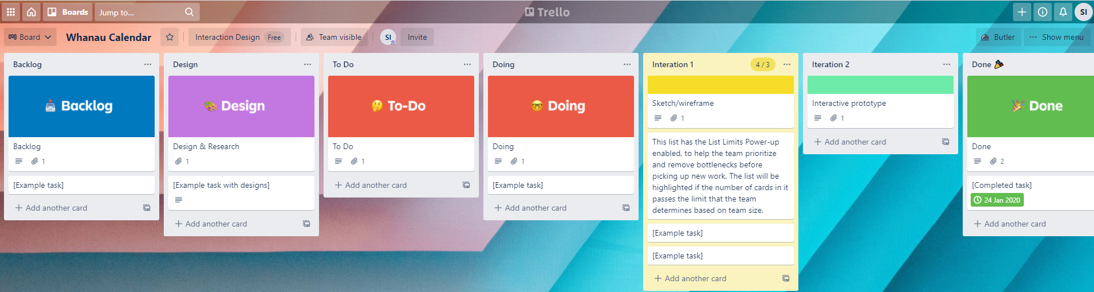

<https://github.com/sharifaisaako/Whanau-family-Calendar>

